The dataset used in this project comes from a 1966 compilation collected in the mid-1950’s by Coleman, Katz and Menzel on the subject of medical innovation. It is part of a collection of network datasets organized by Dr. Linton Freeman, Professor Emeritus of Sociology at the University of California-Irvine.

Four towns in Illinois - Peoria, Bloomington, Quincy, and Galesburg - were used as test locations for measuring the impact of network ties on the adoption of (at that time) the breakthrough antibiotic tetracycline, patented in the U.S. in 1953. Adoption tracking for this dataset begins early in its lifecycle, in November of that year. Tracking lasts until the February 1955 end of the study period.

The questions prompted of the 246 physicians led to the creation of data for three networks, each with a slightly different power structure driving the interactions (bolding indicates a relationship to the naming structure of the objects used in the R code).

*Question 1: "When you need information or* ***advice*** *about questions of therapy where do you usually turn?"* (Professional network based primarily on expertise)

*Question 2: "And who are the three or four physicians with whom you most often find yourself* ***discussing*** *cases or therapy in the course of an ordinary week -- last week for instance?"* (Professional network mingled with personal preference)

*Question 3: "Would you tell me the first names of your three* ***friends*** *whom you see most often socially?"* (Personal network)

Each doctor’s relevant personal and professional history was summarized into each of thirteen characteristics: 1) city of practice, 2) recorded date of tetracycline adoption, 3) years in practice, 4) meetings attended, 5) journal subscriptions, 6) free time activities, 7) discussions, 8) club memberships, 9) friends, 10) time in the community, 11) patient load, 12) physical proximity to other physicians and 13) medical specialty. Permissible values for these are detailed in Appendix 1. These characteristics are attached to each of the three networks as vertex attributes whose class has been set to character to enable ERGM treatments using nodefactor() and nodematch(). None of the characteristics lent themselves to being treated as interval-level data.

One 738 x 246 sociomatrix format is available in a single data file (<http://moreno.ss.uci.edu/ckm.dat>). A minor amount of data munging was necessary to break it apart into the three respective (Advice, Discussion, and Friend) networks. Personal and professional attributes for doctors are in a separate 246 x 13 file (<http://moreno.ss.uci.edu/attributes.dat>) and were also subject to a minimum of data manipulation.

For the purposes of project evaluation, the data files are provided in the upload to the Dropbox and the R code can be sourced to break apart the data, provide examples of analytic rigor, and present the basis for plots used in this document. Alternatively, the files can instead be pulled from the Cal-Irvine server, if so desired. No prior manipulation of the metadata in the header of the files is necessary.

Prior to a more detailed look at community detection, one trivial aspect of network structure needs a bit of commentary, as it impacts the rest of the study: The complete and total lack of interconnectivity outside of the doctors’ city of residence is notable even given characteristics of the era.

Even though the period in question is obviously prior to the creation of the Internet and even prior to the legislation (1956) commissioning the Interstate Highway System, it’s truly odd that there are *zero* social or professional connections spanning cities across the 246 doctors studied in the three networks. In the plots below, isolates were removed (31, 15, and 18 from Advice, Discussion, and Friend networks). The results starkly illustrate the insularity of the relationships:

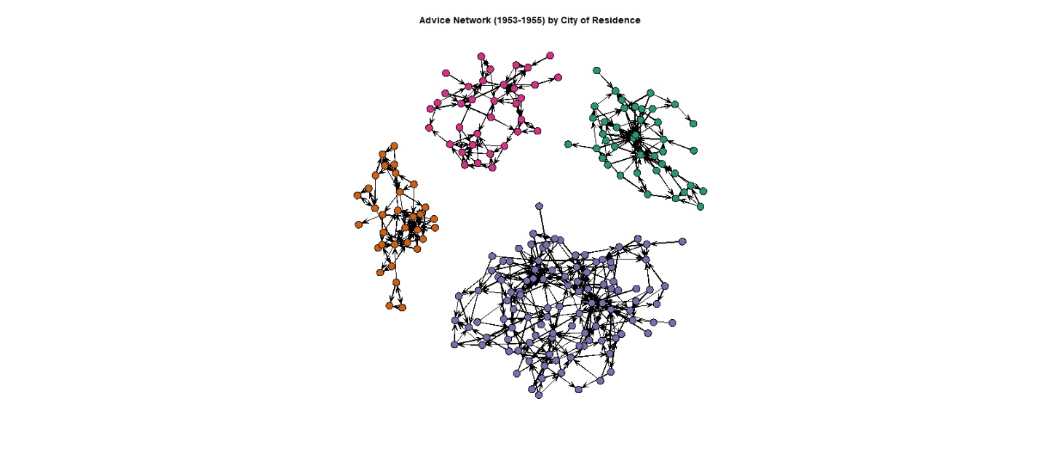 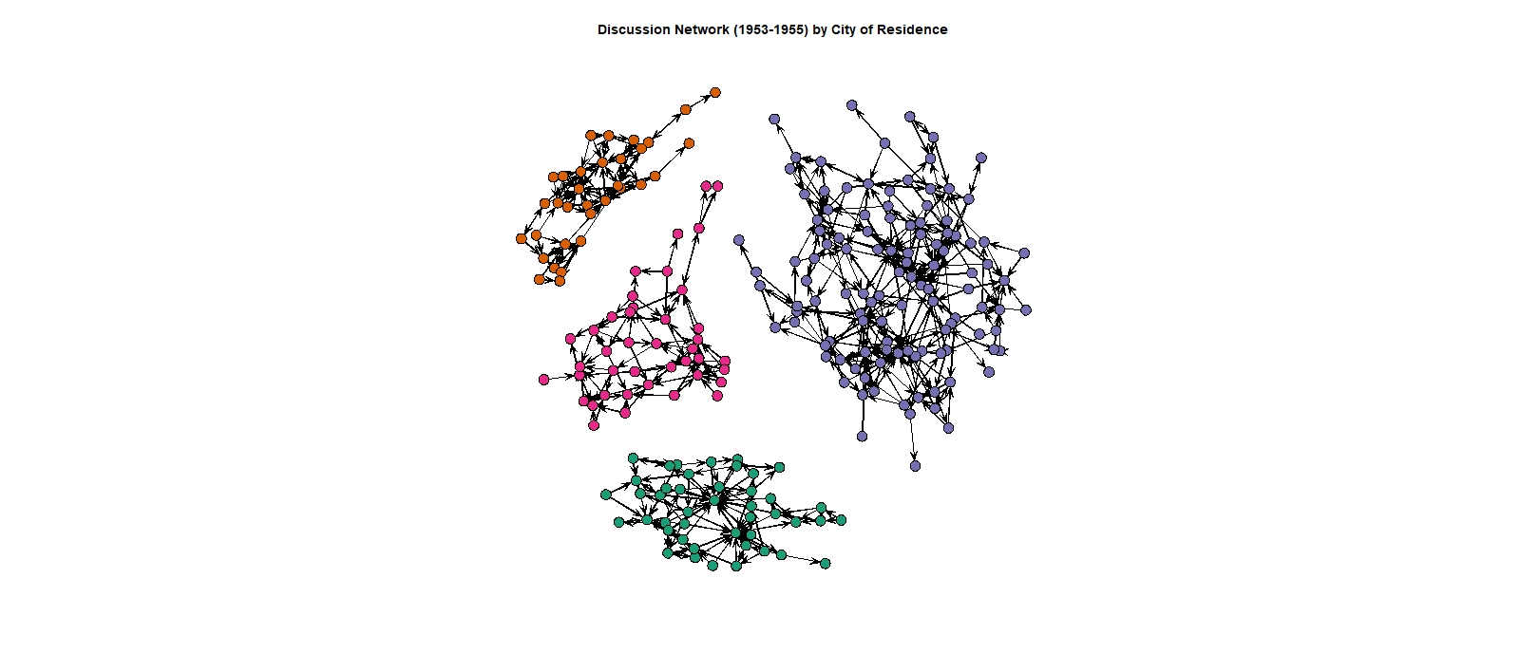

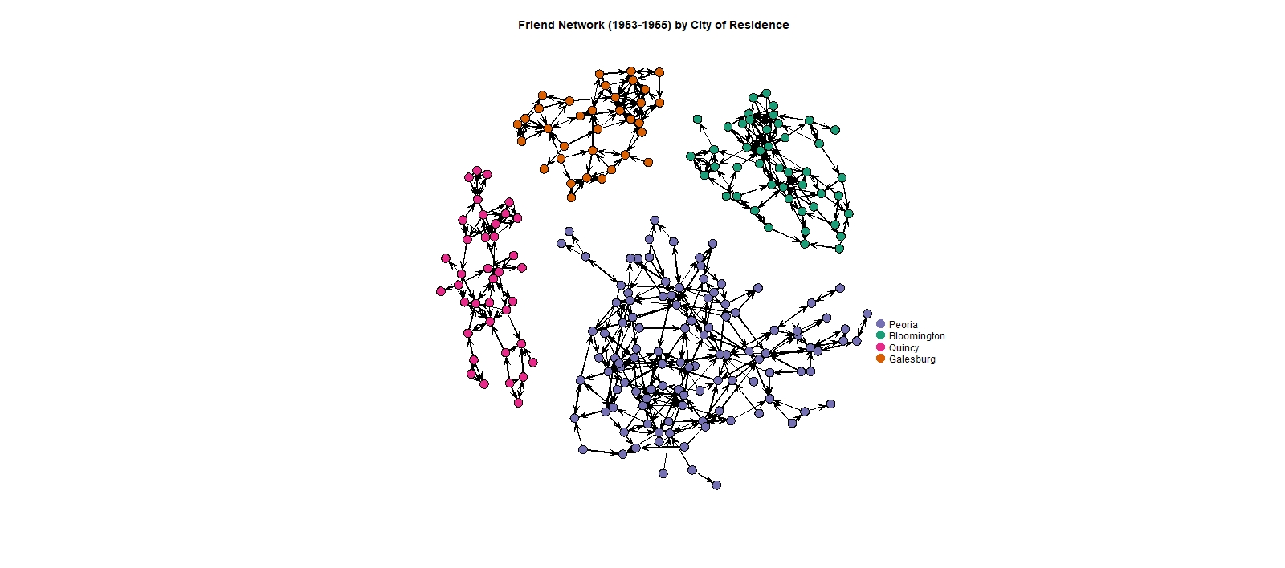

components(advice_net, connected = "weak")

[1] 4

components(friend_net, connected = "weak")

[1] 4

components(discuss_net, connected = "weak")

[1] 4

No professional or personal relationships for this group (if any existed prior) carry over from town to town. No meaningful collegiate or medical school ties seem to remain in place once doctors have started their practice, even if by telephone.

If the state of Illinois made any attempts to spread medical expertise, it did not seem to do so in a way that encouraged the exchange of information outside of one’s immediate vicinity.

Regarding the issue of physical proximity, some of the towns are not even far apart even by mid-1950s traffic standards. Even as measured by today’s transit infrastructure, two city combinations (Galesburg-Peoria and Bloomington-Peoria) are less than 50 miles apart. A complete set of travel distances between cities are noted in Appendix 2.

With the insularity of the three similar-but-different networks established, let us pick for further study the Advice network and consider community measurements based on those that are the primary go-to information providers and their in-degrees of connection. Prestige 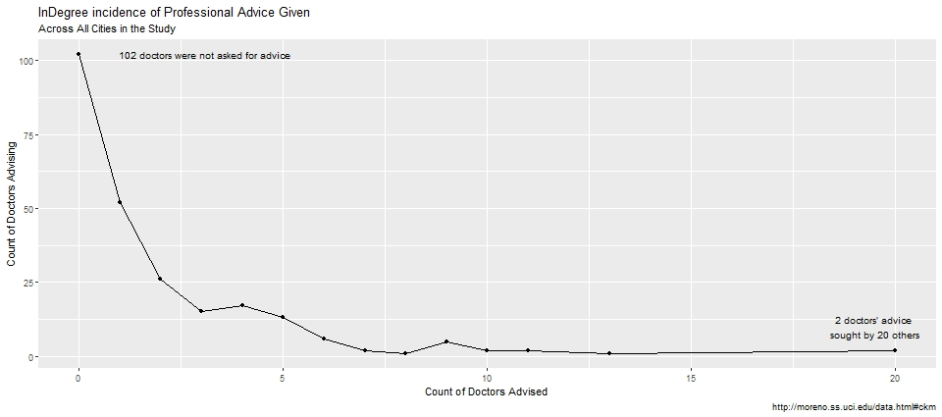measurements for the doctors exhibit a plot indicative of a classic scale-free network, where most doctors are not sought out for advice, yet a small number of doctors exhibit an ‘expert’ status among their associates.

Using the only two algorithms recommended (cluster_edge_betweeness() and infomap()) for directed networks, a by-city search for ‘advice’ communities are considered. As there are no linkages between cities, it makes a singular test moot. The test would come up with four communities.

For each city, both algorithms were attempted, and infomap() provided a more concise set of communities which primarily seemed to be focused on the nodes with a larger number of in-degrees.

Peoria Bloomington Quincy Galesburg

Cluster_Edge_Betweeness 46 17 2 7

InfoMap 14 1 3 4

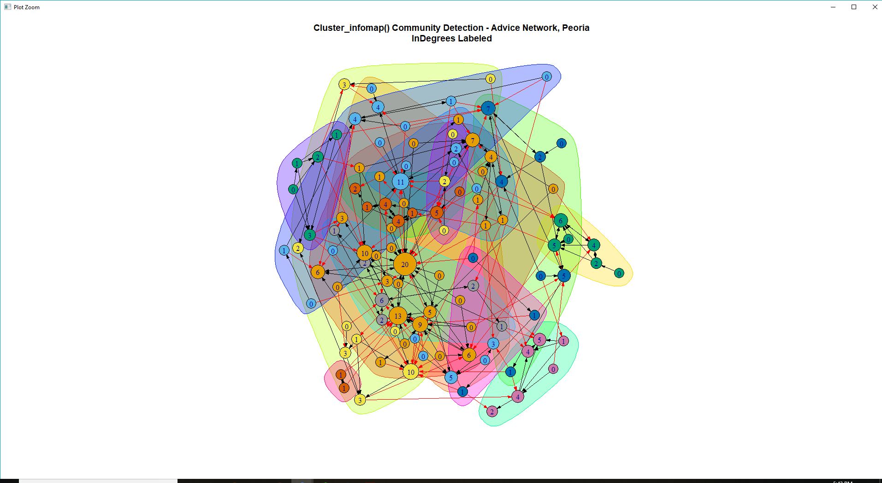Proceeding with the infomap() method of community detection, Peoria’s advice network of 106 doctors is substantially more interesting than the corresponding networks (1, 3, and 4 communities) for the other three cities. For reference, the other community maps can be found in Appendix 3.

The fourteen differently-colored communities detected exhibit black links for intra-community communication, and red links for inter-community communication. The nodes have been sized such that they are reflective of the number of in-degrees, accentuating those that correspond to the doctors whose opinion is more highly sought.

In a subsequent step, we will take node attributes and run an ERGM analysis against them to determine which factors drive doctors in Peoria towards other, go-to advisors. In summary, here are the characteristics of the predictive attributes that will be used. Distinct coding values for the attributes are described in Appendix 1.

|  |
| --- |
| table(V(advice_net_i1)$adoption_date) |
| 1 2 3 4 5 6 7 8 9 10 11 12 13 14 15 18 98 99 |
| 5 4 4 7 6 5 4 4 2 1 3 2 1 2 3 6 41 6 |

Adoption Date: 41 doctors had no tetracycline prescriptions noted, 6 had no prescriptions whatsoever, and 6 did not answer. The rest had their adoption periods spread from the beginning of the survey period (5 in November of 1953) to the end of the survey period (3 in December 1954/January 1955)

|  |
| --- |
| table(V(advice_net_i1)$clubs) |
| 0 1 9 |
| 88 7 11 |

Club memberships: Most doctors (88) chose not to belong to a club or professional organization comprised mostly of other doctors, or chose not to respond (11).

|  |
| --- |
| How long have you been practicing in this community? |
| 1 a year or less |
| 2 more than a year, up to two years |
| 3 more than two years, up to five years |
| 4 more than five years, up to ten years |
| 5 more than ten years, up to twenty years |
| 6 more than twenty years |
| 9 no answer |

Length of medical practice: The medical community in Peoria at the time looked to be a highly-experienced group.

Over half of them had been practicing medicine for ten years or more.

|  |
| --- |
| table(V(advice_net_i1)$community) |
| 1 2 3 4 5 6 9 |
| 6 7 18 17 29 27 2 |

At the other end of the spectrum, only thirteen of them had been in Peoria for two years or less.

|  |
| --- |
| table(V(advice_net_i1)$discuss) |
| 1 2 3 9 |
| 45 50 5 6 |

‘Talking shop’ in social settings: When in the presence of other doctors in a social setting, nearly equal numbers did (45) and didn’t (50), with the remainder either ambivalent or choosing not to disclose.

|  |
| --- |
| table(V(advice_net_i1)$free_time) |
| 1 2 3 9 |
| 54 23 24 5 |

Freedom of Association: Do doctors spend their free time with other physicians? There was a roughly ½, ¼, ¼ split between spending time predominantly with non-doctors, an even split of time between doctors and non-doctors, and time pent predominantly with doctors, with only a few choosing not to respond.

|  |
| --- |
| table(V(advice_net_i1)$friends) |
| 1 2 3 4 9 |
| 42 22 20 11 11 |

Friends’ Occupation: Of the doctors’ three nearest friends, were they doctors as well? 42 doctors had all three of their closest friends outside of the medical profession, while 11 had all three of their friends inside of the medical profession, with 11 also choosing not to disclose.

|  |
| --- |
| table(V(advice_net_i1)$jours) |
| 1 2 3 4 5 6 7 8 9 |
| 6 14 16 23 16 9 7 11 4 |

Medical Journals Received: At the low end, 6 doctors regularly received two medical journals. At the high end, 11 doctors received nine or more journals, with four choosing not to disclose.

|  |
| --- |
| table(V(advice_net_i1)$med_sch_yr) |
| 1 2 3 4 5 6 9 |
| 13 14 16 23 21 15 4 |

Year Graduated from Med School: Outside of the 4 doctors choosing not to report, 13 graduated from medical school in 1919 or before. In the second category, 14 graduated in the ten-year span from 1920 to 1929. From there, the divisions are in five-year increments with 15 doctors graduating in 1945 or later.

|  |
| --- |
| table(V(advice_net_i1)$meetings) |
| 0 1 2 9 |
| 22 33 46 5 |

Meetings Attended: 22 doctors chose not to attend state, regional, or national meetings in the last 12 months prior to the survey. However, the majority attended either general (33) or specialty (46) meetings to further their education.

|  |
| --- |
| table(V(advice_net_i1)$patients) |
| 1 2 3 4 5 6 9 |
| 8 13 17 19 17 17 15 |

Patient Load: Doctors were asked about their level of patient visits over the period that the survey was taken. There were 8 doctors that saw 25 or fewer patients, 13 that saw 26-50 patients with buckets that vary from 25 to 50 in size, with the largest bucket of 17 doctors seeing 150 or more patients. 15 doctors either did not know the extent of their caseload or were unwilling to provide it.

|  |
| --- |
| table(V(advice_net_i1)$proximity) |
| 1 2 3 4 9 |
| 14 32 41 6 13 |

Proximity to Other Physicians: 14 doctors were not in close physical proximity to other doctors on a regular basis. Other buckets describe gradual increases in the partnership exhibited in a multi-physician practice, with 13 choosing not to report.

|  |
| --- |
| table(V(advice_net_i1)$specialty) |
| 1 2 3 4 9 |
| 28 21 10 45 2 |

Practice Specialty: 28 doctors were general practitioners, 21 specialized in internal medicine, while 10 were pediatricians. 45 doctors studied another specialty, and 2 chose not to report.

Prior to modeling the Advice network in ERGM, I hypothesized that the predictors for ties that would have the largest probability would be the ones that emphasized physical contact and/or proximity. Given the inter-city insularity described at the beginning, a 1950s-era group of people would probably primarily seek regular advice from them closest to them in location or from other doctors in their social circle.

The initial step to prep for ERGM was to take the Advice network and subset out just the Peoria vertices. This was facilitated quite easily by just making a copy of the network that already had isolates removed and then to use delete.vertices() against data from the other cities.

advicePeoria_net <- advice_net

delete.vertices(advicePeoria_net, which(advicePeoria_net %v% "city" != "Peoria"))

Next, a null model was built with the edges as the only predictor, supplying a counterpart to the y-intercept term from logistic regression model results. An AIC score was archived as one baseline for determining model usefulness.

nullAdvice <- ergm(advicePeoria_net ~ edges, control = control.ergm(seed = 2112))

AICnull = nullAdvice$glm$aic

print(AICnull)

[1] 2333.675

At the other end of the spectrum, another baseline AIC score was derived by adding in all predictors using nodefactor(). With the data not being conducive to a treatment as continuous data (even the progressively-scaled adoption_date has ‘no adoption’ and ‘did not answer’ buckets), the data were treated as all categorical. The resulting summary of the full model can be found in Appendix 4.

fullAdvice <- ergm(advicePeoria_net ~ edges + nodefactor('proximity') + nodefactor('med_sch_yr')

+ nodefactor('community') + nodefactor('adoption_date') + nodefactor('clubs')

+ nodefactor('discuss') + nodefactor('free_time') + nodefactor('friends')

+ nodefactor('jours') + nodefactor('meetings') + nodefactor('patients')

+ nodefactor('specialty'), control = control.ergm(seed = 2112))

AICfull = fullAdvice$glm$aic

print(AICfull)

[1] 2302.254

While that improved the AIC score and the predictive quality of the model, there were several predictors noted in Appendix 4 that did not look to contribute. These predictors (patients, jours, meetings, proximity, and discuss) were removed in turn, ensuring that AIC decreased accordingly.

# Remove 'discuss' from consideration, does not look to contribute.

Advice5 <- ergm(advicePeoria_net ~ edges + nodefactor('med_sch_yr')

+ nodefactor('community') + nodefactor('adoption_date') + nodefactor('clubs')

+ nodefactor('free_time') + nodefactor('friends')

+ nodefactor('specialty'), control = control.ergm(seed = 2112))

AICAdvice5 = Advice5$glm$aic

modelResults <- c(AICNull = AICnull, AICFull = AICfull, AICAdvice1 = AICAdvice1,

AICAdvice2 = AICAdvice2, AICAdvice3 = AICAdvice3, AICAdvice4 = AICAdvice4,

AICAdvice5 = AICAdvice5)

print(modelResults)

AICNull AICFull AICAdvice1 AICAdvice2 AICAdvice3 AICAdvice4 AICAdvice5

2333.675 2302.254 2293.089 2281.015 2278.976 2276.816 2271.739

# AIC improves without 'discuss'.

No other predictors could be removed without increasing the AIC score. Next, highly-predictive categorical variables that had only a few potential values were modeled as nodematch(diff = T) to see if that would increase model quality. Using nodematch() on ‘Clubs’ and ‘Specialty’ yielded improvement:

# Treating the higher-contributing 'specialty' as nodematch rather than nodefactor yields a better AIC

Advice7 <- ergm(advicePeoria_net ~ edges + nodefactor('med_sch_yr')

+ nodefactor('community') + nodefactor('adoption_date') + nodematch('clubs', diff = T)

+ nodefactor('free_time') + nodefactor('friends')

+ nodematch('specialty', diff = T), control = control.ergm(seed = 2112))

AICAdvice7 = Advice7$glm$aic

modelResults <- c(AICNull = AICnull, AICFull = AICfull, AICAdvice1 = AICAdvice1,

AICAdvice2 = AICAdvice2, AICAdvice3 = AICAdvice3, AICAdvice4 = AICAdvice4,

AICAdvice5 = AICAdvice5, AICAdvice6 = AICAdvice6, AICAdvice7 = AICAdvice7)

print(modelResults)

AICNull AICFull AICAdvice1 AICAdvice2 AICAdvice3 AICAdvice4 AICAdvice5 AICAdvice6 AICAdvice7

2333.675 2302.254 2293.089 2281.015 2278.976 2276.816 2271.739 2268.234 2210.517

Attempting this process on other predictors did not result in a lower AIC, so model refining was concluded. The associated model summary can be found in Appendix 5. The original hypothesis of nearness to other doctors – either socially or professionally – having a large bearing on probability of ties is primarily borne out by the retention of the community, clubs, free time, and friends predictors. However, I would have expected that the discuss and proximity predictors would have been retained.

|  |
| --- |
| oddsratios[c(2:30,34:40),] |
| Lower OR Upper |
| nodefactor.med_sch_yr.2 0.5523 0.9622 1.6762 |
| nodefactor.med_sch_yr.3 0.2680 0.6272 1.4678 |
| nodefactor.med_sch_yr.4 0.1343 0.3112 0.7207 |
| nodefactor.med_sch_yr.5 0.1649 0.3529 0.7554 |
| nodefactor.med_sch_yr.6 0.1435 0.3397 0.8039 |
| ~~nodefactor.med_sch_yr.9 0.7435 10.7224 154.6355~~ |

The relative odds for nodefactor() categorical predictors were calculated and are presented below. Ignoring ‘did not answer’ categories:

Compared to the baseline category for medical school attendance (in 1919 or before), the odds of an advice tie were all substantially lower, and were approximately one-third as likely for the three categories corresponding to 1935 or later. This leads one to believe there was a high seniority component tied to the prevalence of asking another doctor for advice.

|  |
| --- |
| Lower OR Upper |
| nodefactor.community.2 0.8793 1.8277 3.7991 |
| nodefactor.community.3 0.6633 1.3234 2.6405 |
| nodefactor.community.4 0.7638 1.7833 4.1640 |
| nodefactor.community.5 0.8317 2.0851 5.2274 |
| nodefactor.community.6 0.3536 0.8621 2.1020 |
| ~~nodefactor.community.9 0.6059 2.3075 8.7872~~ |

|  |
| --- |
| Lower OR Upper |
| nodefactor.adoption_date.10 0.2142 0.8061 3.0333 |
| nodefactor.adoption_date.11 0.3884 0.9527 2.3367 |
| nodefactor.adoption_date.12 1.6520 7.1585 31.0193 |
| nodefactor.adoption_date.13 0.5391 1.8007 6.0144 |
| nodefactor.adoption_date.14 0.6763 2.0399 6.1524 |
| nodefactor.adoption_date.15 0.8669 2.3163 6.1888 |
| nodefactor.adoption_date.18 0.5693 1.3513 3.2076 |
| nodefactor.adoption_date.2 1.8483 3.7795 7.7284 |
| nodefactor.adoption_date.3 2.6050 5.1162 10.0481 |
| nodefactor.adoption_date.4 0.9999 1.9818 3.9280 |
| nodefactor.adoption_date.5 1.5149 3.1751 6.6550 |
| nodefactor.adoption_date.6 0.7947 1.6932 3.6077 |
| nodefactor.adoption_date.7 0.4470 0.9811 2.1536 |
| nodefactor.adoption_date.8 1.3368 2.6883 5.4062 |
| nodefactor.adoption_date.9 1.3800 3.4256 8.5038 |
| ~~nodefactor.adoption_date.98 0.9104 1.6882 3.1305~~ |
| ~~nodefactor.adoption_date.99 0.2725 0.7004 1.7998~~ |

Compared to the baseline category for adoption date (November 1953), the odds of an advice tie were, in nearly all cases, substantially higher for later adopters than for the early adopters. For adoption date 4 (February 1954), for example, the odds were nearly 200% as likely that a later adopter would have a tie. For adoption date 5 (March 1954), just over 3 times as likely.

Combined with the prior findings that the odds of a tie decrease steadily for more recent graduates of medical school, one possible explanation could be that the early adopters were more recent graduates on the fringes of the network (see excerpt) that were more in tune with medical advances than with doctors that had been out of medical school for quite a while.

Extending that lesson to today’s more interconnected and Internet-driven world, it would pay to not only spend time advancing new concepts towards the young who more easily embrace them, it would be time well spent to also craft targeted messages to those that are older and that have more established personal networks exhibited with a high betweenness centrality factor. That way, a message does not have to be spread *primarily* by early adopters.

|  |
| --- |
| Lower OR Upper |
| nodefactor.free_time.2 0.5717 0.7820 1.0695 |
| nodefactor.free_time.3 0.4073 0.5938 0.8655 |
| ~~nodefactor.free_time.9 0.0060 0.0683 0.7796~~ |

Compared to the baseline category for free time (more spent with non-doctors), the odds of an advice tie for those that spent progressively more time with doctors was between 78 and 59 percent less frequent. Given our findings to this point, that seems counterintuitive.

|  |
| --- |
| Lower OR Upper |
| nodefactor.friends.2 0.9195 1.2237 1.6286 |
| nodefactor.friends.3 1.4318 2.1007 3.0822 |
| nodefactor.friends.4 0.6957 1.1103 1.7720 |
| ~~nodefactor.friends.9 0.5141 0.8235 1.3191~~ |

Compared to the baseline category for friendship (none of their three closest friends are doctors), the odds of an advice tie for those having more friendships with doctors grows per our original hypothesis. Having one of their closest three friends in the profession increased the odds of having an advice tie by 22%, and having two increased the odds of a tie to be over twice as likely.

To conclude this exercise, we compute the probability of a hypothetical Advice ties for Peoria using the Advice7 model in the accompanying code, referenced in Appendix 5:

What is the probability of a tie between two nodes if:

Hypothetical vertex A corresponds to a doctor that graduated medical school in 1931, practiced in the community 1-2 years, was among the earliest adopters of tetracycline (November 1953), spends free time split evenly between doctors and non-doctors, and has one of three close friends that is a doctor.

Hypothetical vertex B corresponds to a doctor that graduated medical school in 1925, practiced in the community 10-20 years, was a later adopter of tetracycline (July 1954), spends free time mostly with doctors, and has two of three close friends that is a doctor.

Match terms: They both are members of clubs, but A is an internist and B is a pediatrician.

The probability is around 35%.

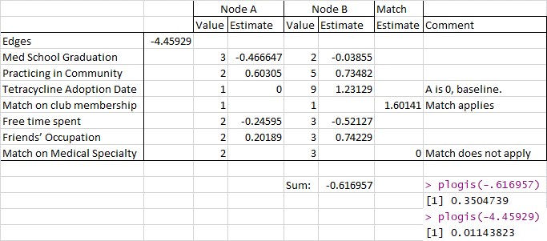

# Probability calculated at end of document

sampleProb <- plogis(Advice7$coef[1] + Advice7$coef[2] + Advice7$coef[3] +

Advice7$coef[8] + Advice7$coef[11] + Advice7$coef[28] +

Advice7$coef[32] + Advice7$coef[34] + Advice7$coef[35] +

Advice7$coef[37] + Advice7$coef[38])

# As compared to null model

nullProb <- plogis(Advice7$coef[1])

sprintf("Null probability of tie = %.2f, Hypothesized probability of tie = %.2f",

nullProb, sampleProb)

"Null probability of tie = 0.01, Hypothesized probability of tie = 0.35"

Bibliography:

Dr. Linton Freeman’s (<http://moreno.ss.uci.edu>) dataset collection: “Coleman, Katz, Menzel --Innovation Among Physicans”: <http://moreno.ss.uci.edu/data.html#ckm>

Data: http://moreno.ss.uci.edu/ckm.dat

Vertex Attributes: <http://moreno.ss.uci.edu/attributes.dat>

Wikipedia: Interstate Highway System: <https://en.wikipedia.org/wiki/Interstate_Highway_System>

Wikipedia: Tetracyline: <https://en.wikipedia.org/wiki/Tetracycline>

Distancesonline.com: Mileage distance calculations (Peoria, Bloomington, Quincy, Galesburg)

Appendix 1: Vertex attributes for physicians

(city) City of residence:

1 Peoria

2 Bloomington

3 Quincy

4 Galesburg

(adoption_date) Tetracycline adoption date:

1 November, 1953 2 December, 1953 3 January, 1954

4 February, 1954 5 March, 1954 6 April, 1954

7 May, 1954 8 June, 1954 9 July, 1954

10 August, 1954 11 September, 1954 12 October, 1954

13 November, 1954 14 December, 1954 15 December/January, 1954/1955

16 January/February, 1955 17 February, 1955 18 no prescriptions found

98 no prescription data obtained

(med_sch_yr) Year started in the profession:

1 1919 or before

2 1920-1929

3 1930-1934

4 1935-1939

5 1940-1944

6 1945 or later

9 no answer

(meetings) Have you attended any national, regional or state conventions of professional societies during the last 12 months? [if yes] Which ones?

0 none

1 only general meetings

2 specialty meetings

9 no answer

(jours) How many medical journals do you receive regularly?

1 two

2 three

3 four

4 five

5 six

6 seven

7 eight

8 nine or more

9 no answer

(free_time) With whom do you actually spend more of your free time -- doctors or non-doctors?

1 non-doctors

2 about evenly split between them

3 doctors

9 missing; no answer, don't know

(discuss) When you are with other doctors socially, do you like to talk about medical matters?

1 no

2 yes

3 don't care

9 missing; no answer, don't know

(clubs) Do you belong to any club or hobby composed mostly of doctors?

0 no

1 yes

9 no answer

(friends) Would you tell me who are your three friends whom you see most often socially? What is [their] occupation?

1 none are doctors

2 one is a doctor

3 two are doctors

4 three are doctors

9 no answer

(community) How long have you been practicing in this community?

1 a year or less

2 more than a year, up to two years

3 more than two years, up to five years

4 more than five years, up to ten years

5 more than ten years, up to twenty years

6 more than twenty years

9 no answer

(patients) About how many office visits would you say you have during the average week at this time of year?

1 25 or less

2 26-50

3 51-75

4 76-100

5 101-150

6 151 or more

9 missing; no answer, don't know

(proximity) Are there other physicians in this building? [if yes] Other physicians in same office or with same waiting room?

1 none in building

2 some in building, but none share his office or waiting room

3 some in building sharing his office or waiting room

4 some in building perhaps sharing his office or waiting room

9 no answer

(specialty) Do you specialize in any particular field of medicine? [if yes] What is it?

1 GP, general practitioner

2 internist

3 pediatrician

4 other specialty

9 no answer

Appendix 2: Driving distances (given today’s infrastructure) between the four cities in the study.

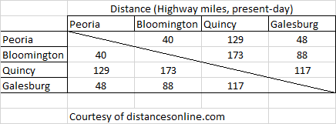

Appendix 3: Remaining community structures for medical advice in Bloomington, Quincy, and Galesburg

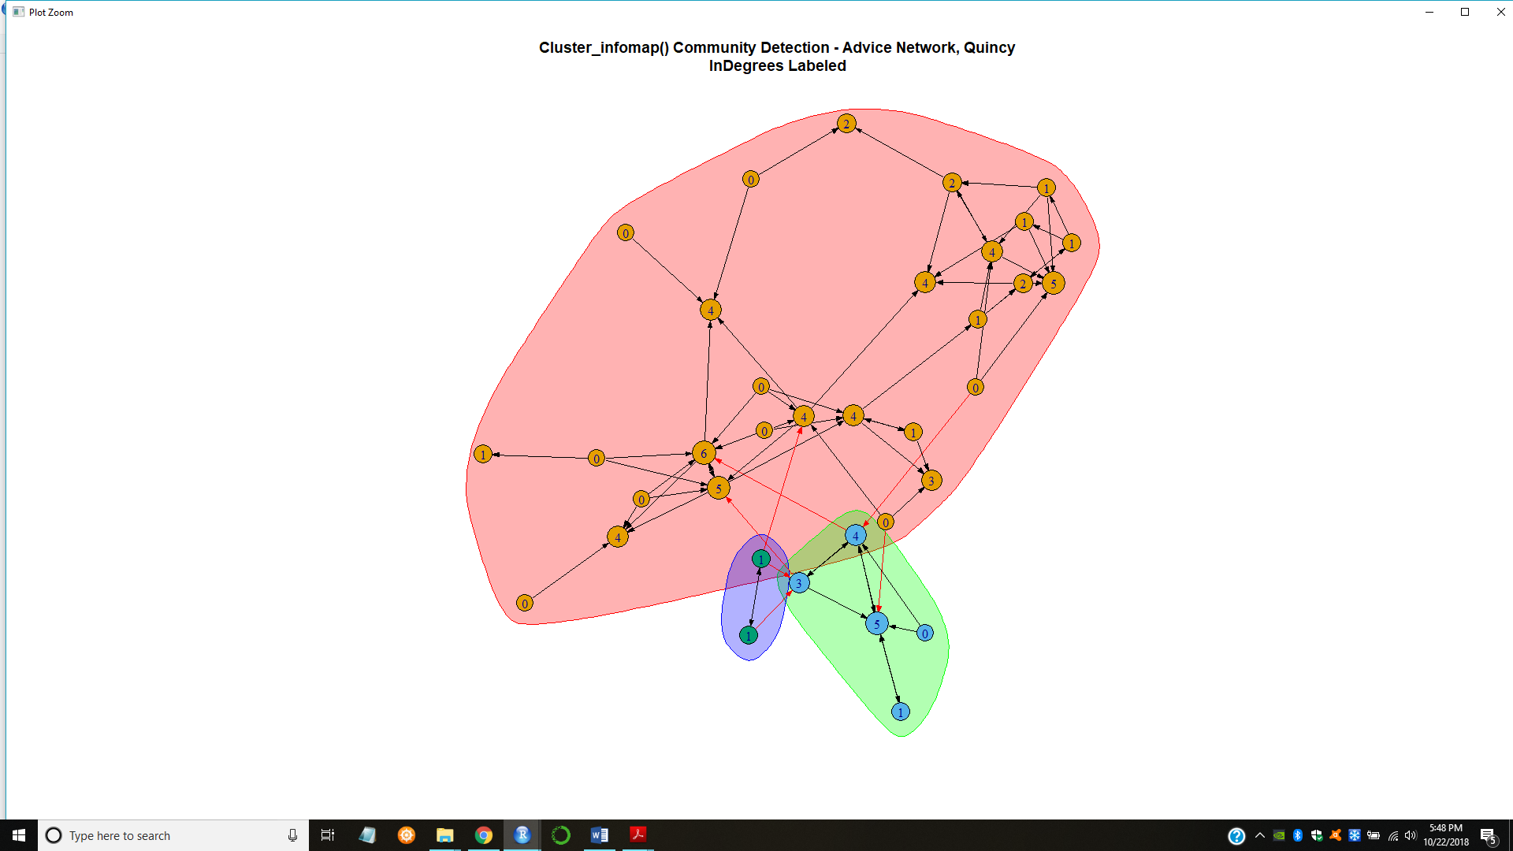 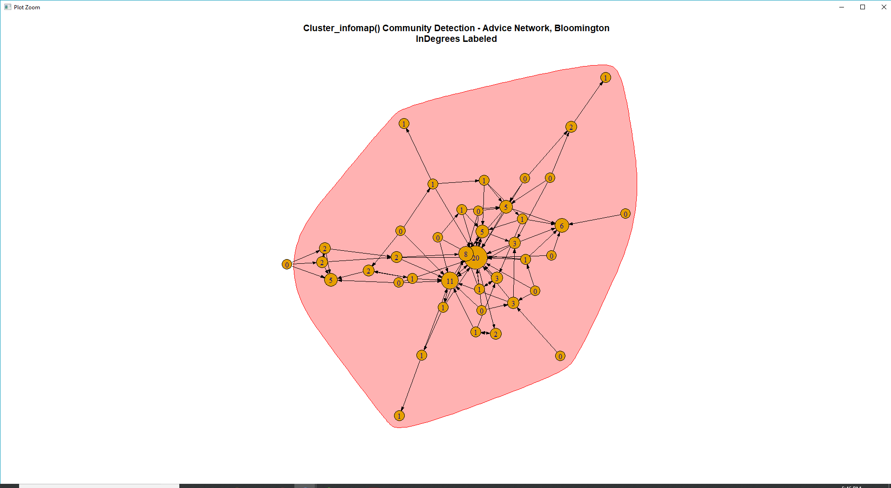

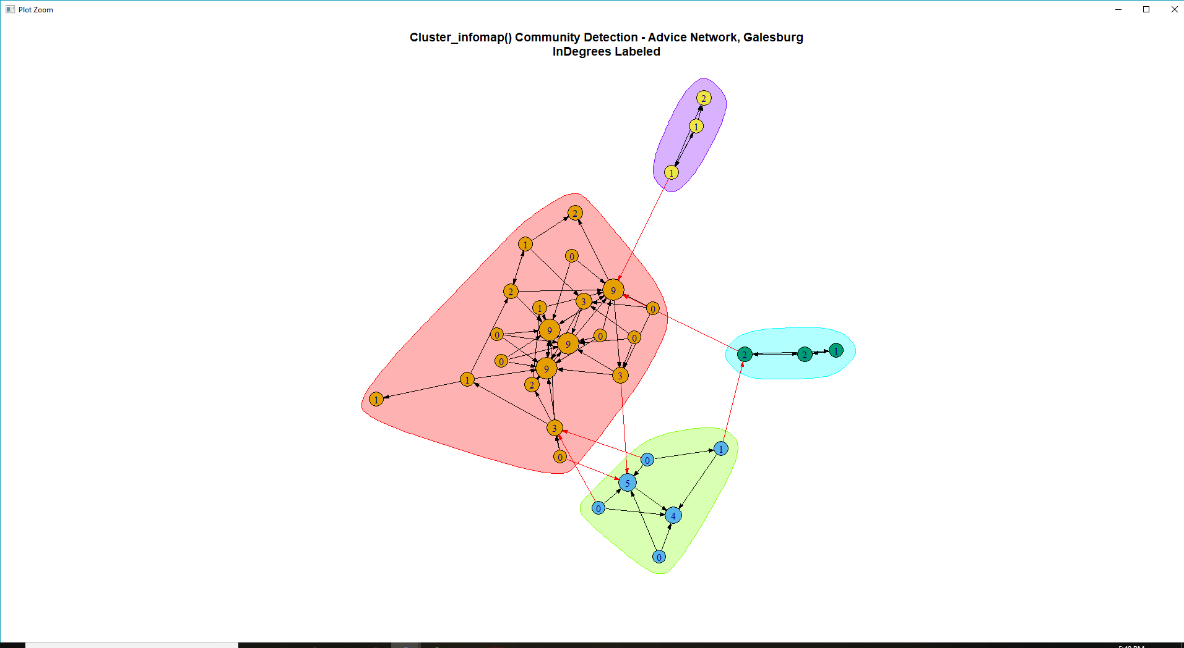

Appendix 4 : ERGM Model with all predictors, prior to reduction

> summary(fullAdvice)

==========================

Summary of model fit

==========================

Formula: advicePeoria_net ~ edges + nodefactor("proximity") + nodefactor("med_sch_yr") +

nodefactor("community") + nodefactor("adoption_date") +

nodefactor("clubs") + nodefactor("discuss") +

nodefactor("free_time") + nodefactor("friends") +

nodefactor("jours") + nodefactor("meetings") +

nodefactor("patients") + nodefactor("specialty")

Iterations: 7 out of 20

Monte Carlo MLE Results:

Estimate Std. Error MCMC % z value Pr(>|z|)

edges -6.525870 1.635922 0 -3.989 < 1e-04 ***

nodefactor.proximity.2 0.253763 0.294751 0 0.861 0.38927

nodefactor.proximity.3 0.273689 0.301365 0 0.908 0.36379

nodefactor.proximity.4 0.293969 0.381791 0 0.770 0.44132

nodefactor.proximity.9 -0.320136 0.399472 0 -0.801 0.42290

nodefactor.med_sch_yr.2 0.095691 0.362926 0 0.264 0.79204

nodefactor.med_sch_yr.3 -0.884821 0.683587 0 -1.294 0.19553

nodefactor.med_sch_yr.4 -1.432976 0.689405 0 -2.079 0.03766 *

nodefactor.med_sch_yr.5 -1.158861 0.594977 0 -1.948 0.05145 .

nodefactor.med_sch_yr.6 -1.050297 0.665698 0 -1.578 0.11463

nodefactor.med_sch_yr.9 2.108349 1.718226 0 1.227 0.21980

nodefactor.community.2 0.600291 0.437461 0 1.372 0.17000

nodefactor.community.3 0.406327 0.409790 0 0.992 0.32142

nodefactor.community.4 0.815299 0.545779 0 1.494 0.13522

nodefactor.community.5 1.141430 0.598725 0 1.906 0.05659 .

nodefactor.community.6 -0.325952 0.622988 0 -0.523 0.60083

nodefactor.community.9 0.466132 0.984539 0 0.473 0.63589

nodefactor.adoption_date.10 -0.483879 0.824766 0 -0.587 0.55741

nodefactor.adoption_date.11 -0.273925 0.585962 0 -0.467 0.64016

nodefactor.adoption_date.12 1.585543 0.929933 0 1.705 0.08819 .

nodefactor.adoption_date.13 0.885484 0.932538 0 0.950 0.34234

nodefactor.adoption_date.14 0.480682 0.828158 0 0.580 0.56163

nodefactor.adoption_date.15 0.433741 0.599070 0 0.724 0.46905

nodefactor.adoption_date.18 0.408235 0.591571 0 0.690 0.49014

nodefactor.adoption_date.2 0.801991 0.464354 0 1.727 0.08415 .

nodefactor.adoption_date.3 1.325038 0.423595 0 3.128 0.00176 **

nodefactor.adoption_date.4 0.483250 0.413752 0 1.168 0.24282

nodefactor.adoption_date.5 0.685772 0.430234 0 1.594 0.11095

nodefactor.adoption_date.6 0.286766 0.479286 0 0.598 0.54963

nodefactor.adoption_date.7 0.143780 0.482995 0 0.298 0.76594

nodefactor.adoption_date.8 0.599281 0.428105 0 1.400 0.16156

nodefactor.adoption_date.9 0.844114 0.684308 0 1.234 0.21738

nodefactor.adoption_date.98 0.539778 0.715668 0 0.754 0.45071

nodefactor.adoption_date.99 -0.212930 0.982261 0 -0.217 0.82838

nodefactor.clubs.1 0.303180 0.282015 0 1.075 0.28235

nodefactor.clubs.9 0.478728 0.389546 0 1.229 0.21909

nodefactor.discuss.2 0.101321 0.161500 0 0.627 0.53041

nodefactor.discuss.3 -0.041545 0.389146 0 -0.107 0.91498

nodefactor.discuss.9 -0.226406 1.468775 0 -0.154 0.87749

nodefactor.free_time.2 -0.269904 0.181739 0 -1.485 0.13751

nodefactor.free_time.3 -0.534169 0.244360 0 -2.186 0.02882 *

nodefactor.free_time.9 -1.977819 2.124182 0 -0.931 0.35180

nodefactor.friends.2 0.082620 0.192836 0 0.428 0.66832

nodefactor.friends.3 0.761508 0.242737 0 3.137 0.00171 **

nodefactor.friends.4 0.206507 0.286013 0 0.722 0.47028

nodefactor.friends.9 -0.268405 0.297055 0 -0.904 0.36623

nodefactor.jours.2 0.351638 0.569801 0 0.617 0.53715

nodefactor.jours.3 0.161043 0.488548 0 0.330 0.74168

nodefactor.jours.4 0.149354 0.482280 0 0.310 0.75680

nodefactor.jours.5 0.275652 0.507160 0 0.544 0.58677

nodefactor.jours.6 -0.022060 0.529706 0 -0.042 0.96678

nodefactor.jours.7 0.193055 0.552267 0 0.350 0.72666

nodefactor.jours.8 0.258016 0.511235 0 0.505 0.61378

nodefactor.jours.9 0.566695 1.156786 0 0.490 0.62421

nodefactor.meetings.1 0.003056 0.277026 0 0.011 0.99120

nodefactor.meetings.2 0.180666 0.264161 0 0.684 0.49402

nodefactor.meetings.9 NA 0.000000 0 NA NA

nodefactor.patients.2 0.390519 0.314065 0 1.243 0.21371

nodefactor.patients.3 0.235930 0.356127 0 0.662 0.50766

nodefactor.patients.4 0.189449 0.405304 0 0.467 0.64020

nodefactor.patients.5 0.288492 0.356020 0 0.810 0.41775

nodefactor.patients.6 0.128223 0.348782 0 0.368 0.71315

nodefactor.patients.9 0.465966 0.392238 0 1.188 0.23485

nodefactor.specialty.2 0.777129 0.296311 0 2.623 0.00872 **

nodefactor.specialty.3 0.567641 0.409018 0 1.388 0.16519

nodefactor.specialty.4 0.236457 0.660826 0 0.358 0.72048

nodefactor.specialty.9 NA 0.000000 0 NA NA

---

Signif. codes: 0 ‘***’ 0.001 ‘**’ 0.01 ‘*’ 0.05 ‘.’ 0.1 ‘ ’ 1

Null Deviance: 15429 on 11130 degrees of freedom

Residual Deviance: 2172 on 11063 degrees of freedom

AIC: 2306 BIC: 2797 (Smaller is better.)

Appendix 5: Final model

> summary(Advice7)

==========================

Summary of model fit

==========================

Formula: advicePeoria_net ~ edges + nodefactor("med_sch_yr") + nodefactor("community") +

nodefactor("adoption_date") + nodematch("clubs",

diff = T) + nodefactor("free_time") + nodefactor("friends") +

nodematch("specialty", diff = T)

Iterations: 7 out of 20

Monte Carlo MLE Results:

Estimate Std. Error MCMC % z value Pr(>|z|)

edges -4.45929 1.17318 0 -3.801 0.000144 ***

nodefactor.med_sch_yr.2 -0.03855 0.28320 0 -0.136 0.891733

nodefactor.med_sch_yr.3 -0.46647 0.43379 0 -1.075 0.282233

nodefactor.med_sch_yr.4 -1.16745 0.42856 0 -2.724 0.006447 **

nodefactor.med_sch_yr.5 -1.04157 0.38829 0 -2.682 0.007309 **

nodefactor.med_sch_yr.6 -1.07982 0.43954 0 -2.457 0.014023 *

nodefactor.med_sch_yr.9 2.37234 1.36160 0 1.742 0.081452 .

nodefactor.community.2 0.60305 0.37332 0 1.615 0.106232

nodefactor.community.3 0.28020 0.35243 0 0.795 0.426589

nodefactor.community.4 0.57849 0.43264 0 1.337 0.181189

nodefactor.community.5 0.73482 0.46892 0 1.567 0.117104

nodefactor.community.6 -0.14842 0.45475 0 -0.326 0.744140

nodefactor.community.9 0.83615 0.68222 0 1.226 0.220336

nodefactor.adoption_date.10 -0.21551 0.67610 0 -0.319 0.749909

nodefactor.adoption_date.11 -0.04845 0.45775 0 -0.106 0.915699

nodefactor.adoption_date.12 1.96830 0.74812 0 2.631 0.008514 **

nodefactor.adoption_date.13 0.58816 0.61530 0 0.956 0.339132

nodefactor.adoption_date.14 0.71289 0.56324 0 1.266 0.205621

nodefactor.adoption_date.15 0.83996 0.50142 0 1.675 0.093900 .

nodefactor.adoption_date.18 0.30108 0.44105 0 0.683 0.494836

nodefactor.adoption_date.2 1.32959 0.36496 0 3.643 0.000269 ***

nodefactor.adoption_date.3 1.63242 0.34437 0 4.740 < 1e-04 ***

nodefactor.adoption_date.4 0.68403 0.34903 0 1.960 0.050020 .

nodefactor.adoption_date.5 1.15534 0.37756 0 3.060 0.002213 **

nodefactor.adoption_date.6 0.52664 0.38594 0 1.365 0.172384

nodefactor.adoption_date.7 -0.01906 0.40112 0 -0.048 0.962104

nodefactor.adoption_date.8 0.98890 0.35645 0 2.774 0.005532 **

nodefactor.adoption_date.9 1.23129 0.46389 0 2.654 0.007948 **

nodefactor.adoption_date.98 0.52364 0.31508 0 1.662 0.096527 .

nodefactor.adoption_date.99 -0.35615 0.48153 0 -0.740 0.459534

nodematch.clubs.0 -0.50375 0.18246 0 -2.761 0.005764 **

nodematch.clubs.1 1.60141 0.55762 0 2.872 0.004080 **

nodematch.clubs.9 0.77704 0.62689 0 1.240 0.215155

nodefactor.free_time.2 -0.24595 0.15976 0 -1.540 0.123671

nodefactor.free_time.3 -0.52127 0.19227 0 -2.711 0.006706 **

nodefactor.free_time.9 -2.68437 1.24258 0 -2.160 0.030747 *

nodefactor.friends.2 0.20189 0.14584 0 1.384 0.166259

nodefactor.friends.3 0.74229 0.19559 0 3.795 0.000148 ***

nodefactor.friends.4 0.10461 0.23852 0 0.439 0.660963

nodefactor.friends.9 -0.19424 0.24039 0 -0.808 0.419072

nodematch.specialty.1 -0.71732 0.40526 0 -1.770 0.076724 .

nodematch.specialty.2 1.36484 0.27836 0 4.903 < 1e-04 ***

nodematch.specialty.3 2.94952 0.40960 0 7.201 < 1e-04 ***

nodematch.specialty.4 0.92996 0.28270 0 3.290 0.001004 **

nodematch.specialty.9 -Inf 0.00000 0 -Inf < 1e-04 ***

---

Signif. codes: 0 ‘***’ 0.001 ‘**’ 0.01 ‘*’ 0.05 ‘.’ 0.1 ‘ ’ 1

Null Deviance: 15429 on 11130 degrees of freedom

Residual Deviance: 2125 on 11085 degrees of freedom

AIC: 2215 BIC: 2545 (Smaller is better.)

Warning: The following terms have infinite coefficient estimates:

nodematch.specialty.9